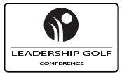

THE PROGRAM OF THE EVENT

Day 1 (11/15/2021)

10.00 - 10.30 Opening of the conference. Norbert ZATKO, Founder of ENGO Group

10.30 – 11.30 Peter HARRADINE, Harradine Golf Design
How the design of golf courses reflects modern challenges and changes in the game

11.30 – 12.00 COFFEE BREAK

12.00 – 13.00 Nick BROWN, Campey Turf Care
Equipment for the care of golf courses, including novelties of Campey Turf Care

13.00 - 13.30 Denis KOLTYKHOV, Association of Greenkeepers of Russia
Association of Greenkeepers of Russia - current tasks and prospects

13.30 – 14.00 John MOORE, Smithco & Turfco
Trends in golf course maintenance

14.00 - 15.00 LUNCH

Day 2 (11/16/2021)

10.00 – 11.00 David STONIER, Campey Turf Care
How to improve the playing qualities of a golf course with the use of special equipment?

11.00 – 12.00 Craig HANNEY, TurfGrass
Economic and environmental component in the maintenance of golf courses

12.00 - 12.30 COFFEE BREAK

12.30 – 13.30 Nick WELLER, Campey Turf Care
Practical care of the golf course Jebel Ali

13.30 – 14.30 Norbert ZATKO, ENGO Group
TORO irrigation, new technologies and advantages over competitors

14.00 - 15.00 LUNCH

Day 3 (17.11.2021)

GOLF TOURNAMENT "Jebel Ali Invitational". FESTIVE DINNER

Day 4/5 (18.11.2021- 19.11.2021)

Free time

We develop and improve professional skills and knowledge
We meet, get acquainted and exchange experiences!

Learn more about the event, program and speakers:
Leadership Golf Conference 2021 Dubai

Register:
Register for LGC 2021 Dubai

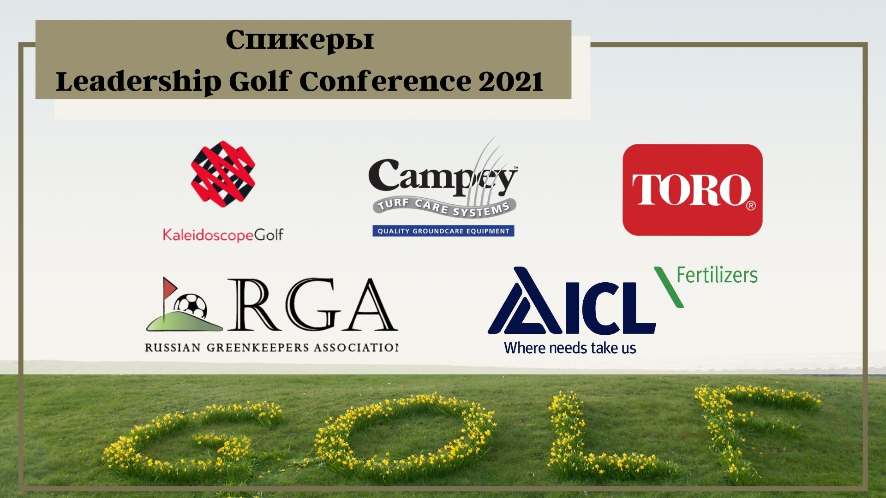

Website: www.leadershipgolfconference.eu
Social media page: http://www.facebook.com/leadershipgolfevent
Questions to the organizers: www.engorussia.ru/kontakty
Phone: +7 903 67 67 890, +7 919 696 40 00
E-mail: Klyuchko@engorussia.ru, ilnur@engorussia.ru

